Personal Knowledge Graph Ontology for Web

Eleni Ilkou[1], Davide Taibi[2], Marco Fisichella[1], and Tetiana Tolmachova[1]
[1]: L3S Research Center, Leibniz University of Hannover, Germany [2]: Institute for Educational Technology, National Research Council of Italy
For more information please access the GitHub page and Resource page

Abstract
Web search engines thrive towards personalisation. At the same time, Personal Knowledge Graphs are gaining momentum as smaller graphs with user's related data on top of larger Knowledge Graphs. The PKG ontology aims to model the constructive aspects of a personal knowledge graph in the backend of a web search application while addressing privacy and accessibility concerns and FAIR principles. This work presents an overview of the ontology description and discusses use cases.
Keywords: Ontology, Personalized Knowledge Graph, Collaborative Learning.

PKG ontology
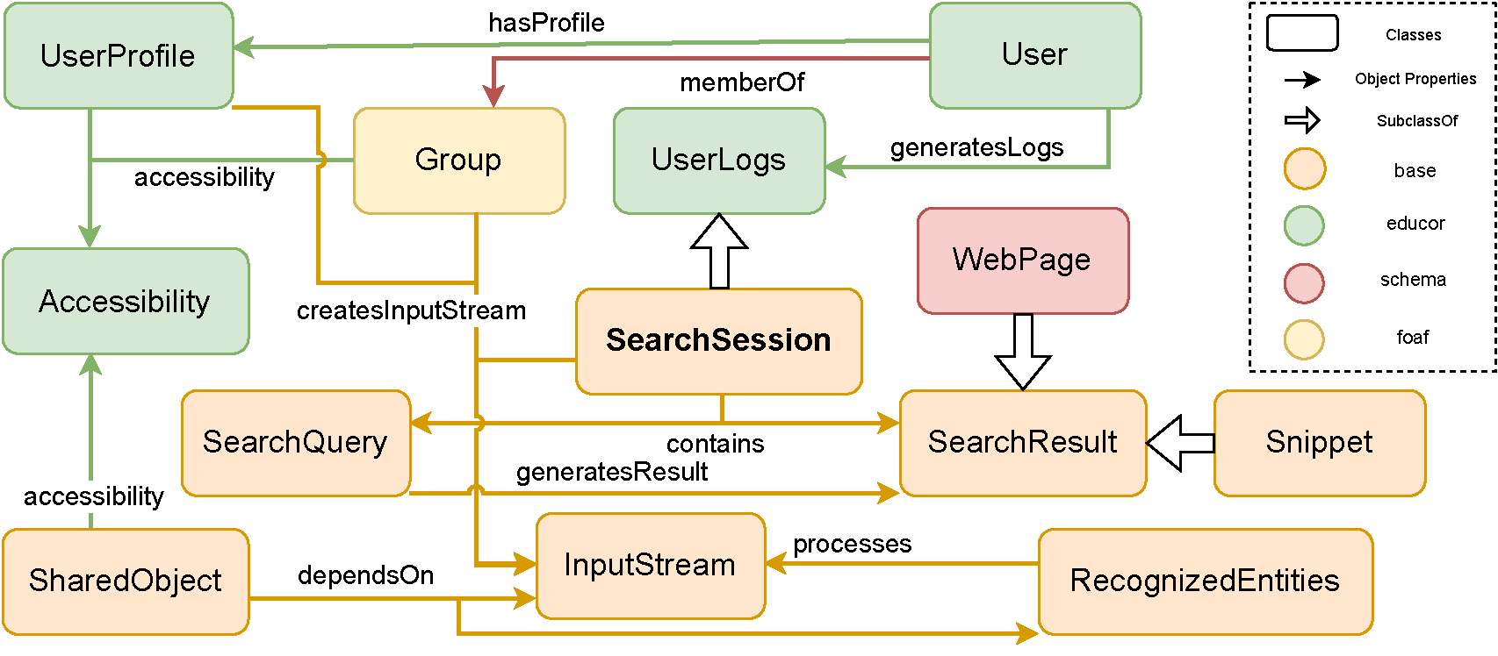

Namespaces used in PKG ontology
Syntax | Description
base | https://github.com/tibonto/pkg/
educor | https://github.com/tibonto/educor#
schema | https://schema.org/
foaf | http://xmlns.com/foaf/spec/

Acknowledgements
We would like to thank Dr. Javad Chamanara for setting up the ontology page. This work was partially funded by EU H2020 project KnowGraphs (GA no. 860801).

